2]Check if there are any two Equal numbers in an array at a distance less than or equal to k
Brute Force :- Just Use 2 For loops and check if distance between any 2 Equal elements is less than or equal to k, print(yes), otherwise, we will print (no)
Optimised using Hashmaps:-
For every element, we need to check only the last Occurence or the Last index where this element has occurred before. We can use a hashmap which will tell us the Last occurrence where this element has occurred.
We just need to calculate the distance between current Occurence and Last Occurence of Current Element.
If this Distance <= k, we have found a valid pair. We will return true. Otherwise, We will return false because we are now sure that we have not found any valid pair of equal elements whose distance btw them is <= k.
def contains_nearby_duplicate_optimized(nums, k):
num_indices = {}
for i, num in enumerate(nums):
if num in num_indices and i - num_indices[num] <= k:
return True
num_indices[num] = i
return False

3] Count All ((i,j) pairs such that b[i] - b[j] == k (count of such pairs.) [i<j]

from collections import defaultdict

def count_pairs_optimized(b, k):
count = 0
freq_map = defaultdict(int)

for num in b:
target = num - k
count += freq_map[target]
freq_map[num] += 1

return count

Optimised Approach:- Instead of Running 2 Nested For loops, we will create a Hashmap to Store the Occurences of the Elements which we have encountered in the past. At each index i, we will calculate the Required Element, = (arr[i]+k), we wil check if it is present in hashmap, we will do cnt = cnt + freq[requiredElement]. We will update the frequency for current element in hashmap.

freq_map[x] stores how many times x has appeared so far.
For each num, check whether a matching value (num - k) has already been seen:
count += freq_map[num - k]
If freq_map[num-k] = 3, that means 3 previous numbers can pair with num, so count increases by 3 at once.
Then record current number:
freq_map[num] += 1
This avoids nested loops and counts pairs in O(n) time.

4] Count all i,j pairs where i<j and abs(b[i]-b[j]) = k [k>=0]
Brute Force Approach:- Use 2 Nested For Loops and for every i, start j from i+1 and go till n-1 -> because j>i(given in problem) -> Check if Absolute Difference between (b[i] and b[j] == k) -> If yes then do count = count + 1 -> Finally Print this Count of All Valid Pairs in Output :)

Optimised Approach:- Fix each “b[j]” and for every b[j] -> you have to find how many valid “i” exist in the range [0…..j-1] such that abs(b[i]-b[j])==k

Applying Maths -> there are two possible cases for this equation :-
-> abs(b[i]-b[j])==k means -> i)b[i]-b[j]==>k or ii) -1*(b[i]-b[j])==>k

-> b[i] - b[j] ⇒ k or b[j] - b[i] ⇒ k

-> b[i] ⇒ k + b[j] or b[i] ⇒ b[j] - k

So if you are able to find such a b[i] in range {0……j-1} then knowing the frequency of such b[i] in range [0…..j-1] tells you many valid pairs are possible (i,j) where “j” is fixed currently and i goes from 0 to j-1

B[i] will be calculated using following 2 formulas:-

B[i] = b[j] + k
B[i] = b[j] – k

def count_pairs_with_difference_k(b, k):
count = 0
freq = {}
for j in range(len(b)):
if b[j] - k in freq:
count += freq[b[j] - k]
if k != 0 and b[j] + k in freq: # to avoid double counting when k = 0
count += freq[b[j] + k]
if b[j] in freq:
freq[b[j]] += 1
else:
freq[b[j]] = 1
return count

5]Find Sum of Range [l……….r] where(l<=r) using Prefix sum.

Brute Force:- For each l and r, start our i pointer from l and i will go till r and for each i, we will update our sum by doing sum = sum + arr[i]. Finally, print this sum.
Time Complexity - O(N*Q)
For each query of l and r, we will call this getSum(), so Time Complexity will be O(n*q) where, q is the size of queries array containing different l and r values.

Space Complexity - O(1)

Optimised Approach:- For given array, construct a prefix array of size n, and prefix[i] = prefix[i-1] + arr[i]. After creating this prefix Array.

For any given l and r,
Sum of the elements in arr in the Range of [l … r] = Prefix[r] - prefix[l-1]

def prefix_sum(nums):
prefix = [0] * (len(nums) + 1)
for i in range(1, len(nums) + 1):
prefix[i] = prefix[i - 1] + nums[i - 1]
return prefix

def optimized_sum(prefix, l, r):
return prefix[r] - prefix[l - 1]

here prefix[0] will remain 0, arr[0] will be stored in prefix[1], because we are using users l and r value to fetch answer

Time Complexity - O(N+Q)
O(n) for creating Prefix Array
O(q) for Traversing Queries

Space Complexity - O(N) Because of Prefix Array

6] Find count of number of subarrays with sum == k

Brute force approach 1:- For Every Index j, We will count the number of Valid Subarrays which have Sum as K and Ending at index j.

After landing at j, we will intiailize sum=arr[j], if sum==k, count++,
Use backward iteration, sum+=arr[i], sum==k? ,count++

Time Complexity - O(N*N)
Space Complexity - O(1)

Brute Force Approach 2 –

use prefix sum, upon landing in j in prefix array, iterate backwards too see if p[i]-k is present

Time Complexity - O(N*N)
Space Complexity - O(N)

Optimised Approach:- Maintain the Prefix sum array and for every index J we will calculate X which will be equal to sum of elements till index j - k (X = P[j]-k). Now, do cnt = cnt + freq[x]
And update freq of current sum as freq[currentSum]++

def count_subarrays_optimized(arr, k):
from collections import defaultdict

prefix_sum_count = defaultdict(int)
current_sum = 0
count = 0

prefix_sum_count[0] = 1

for num in arr:
current_sum += num

if (current_sum - k) in prefix_sum_count:
count += prefix_sum_count[current_sum - k]

prefix_sum_count[current_sum] += 1

return count

Time Complexity - O(N)
Space Complexity - O(N)

Dsgcsuihd
Sqjdbhqiodjqs
Wqhsiqsjs
Saidhqi

7] Find largest/smallest subarray with sum k in Given Array

Brute Force Approach:- We will use 2 Nested for loop and where i will start from index 1 and it will end at index N. similarly J will start from i it will end at N and I denotes the starting point of any subarray and J will denote the ending point of any subarray.

Now we will check if the sum of the elements present in the current sub array is equal to K we will update the maximum length with the current sub array's length

Optimised Approach:- Use the Hashmap and for every j, we will calculate i using formula p[i-1] = p[j] - k. Now we will check in map for the index where p[i-1] has come. We will calculate current Length using j-i+1 and compare this length with Max and Min length and Update them if necessary.

def largest_subarray_sum_k(arr, k):
prefix_sum = 0
first_seen = {0: -1}
max_len = 0

for i, num in enumerate(arr):
prefix_sum += num

if (prefix_sum - k) in first_seen:
max_len = max(max_len, i - first_seen[prefix_sum - k])

if prefix_sum not in first_seen:
first_seen[prefix_sum] = i

return max_len

def smallest_subarray_sum_k(arr, k):
prefix_sum = 0
last_seen = {0: -1}
min_len = float('inf')

for i, num in enumerate(arr):
prefix_sum += num

if (prefix_sum - k) in last_seen:
min_len = min(min_len, i - last_seen[prefix_sum - k])

last_seen[prefix_sum] = i

return 0 if min_len == float('inf') else min_len

8] Find count of shortest/largest subarrays with sum k in given array

Brute Force Approach:- Use 2 Nested For loops, i will denote starting point of subarray and j will denote point of subarray, now we will check if sum of elements of current subarray is equal to k, we will compare its length with maxSize and minSize and update the count Accordingly

Optimised Approach:- First Calculate size of Largest subarray and Smallest Subarray with sum of Elements as k using Maps. Now, just calculate the count of those subarrays which have size as calculated above and sum of elements as k.

def find_subarray_sizes(n, k, arr):
mp = {0: 0}
mp2 = {0: 0}
pSum = 0
maxLength = 0
minLength = float('inf')
for j in range(1, n + 1):
pSum += arr[j - 1]
x = pSum - k
if x in mp:
i = mp[x] + 1
curLength = j - i + 1
if curLength > maxLength:
maxLength = curLength

if x in mp2:
i = mp2[x] + 1
curLength = j - i + 1
if curLength < minLength:
minLength = curLength

if pSum not in mp:
mp[pSum] = j
mp2[pSum] = j
return maxLength, minLength

def count_subarrays_with_length(n, k, arr, targetLength):
if targetLength == 0:
return 0
count = 0

windowSum = sum(arr[:targetLength])
if windowSum == k:
count += 1
for j in range(targetLength, n):
windowSum += arr[j] - arr[j - targetLength]
if windowSum == k:
count += 1
return count
n = 6
k = 5
arr = [1, 2, 3, 4, 2, 5]
maxLength, minLength = find_subarray_sizes(n, k, arr)
maxCount = count_subarrays_with_length(n, k, arr, maxLength)
minCount = count_subarrays_with_length(n, k, arr, minLength)
print("Max Length:", maxLength, "Count:", maxCount)
print("Min Length:", minLength, "Count:", minCount)

9]Valid Anagrams
Problem Link - https://leetcode.com/problems/valid-anagram/

Observation - The Number of times a Particular Character is coming in String 1, Same no. of times it should come in string 2 also.
Reason -> It is mentioned in the problem statement that we cannot add or remove any characters from string 1, we can just rearrange it’s characters

Understanding of the Problem → We want to check if count of all characters is Equal in both Strings, then these strings will be called Anagrams

Brute Force - Sorting Strings

Time Complexity - O(NLogn)
Space Complexity - O(1) + Space Complexity Used in Sorting Depending upon your Programming Language.

Optimization - 1

Using 2 Hashmaps

Optimisation - 2

Using only 1 Hashmap

def isAnagram(s, t):
if len(s) != len(t):
return False

freq = {}

for ch in s:
freq[ch] = freq.get(ch, 0) + 1

for ch in t:
if ch not in freq:
return False

freq[ch] -= 1

if freq[ch] < 0:
return False

if freq[ch] == 0:
del freq[ch]

return not freq

10] Given an array find two subarrays of maximum sum which are not intersecting
(Both the subarrays are allowed to be 0)

B = [5 8 10 2 5 5]

P[i] = sum of the first “i” numbers in the array

for(i=1;i<=n;i++){

p[i] = p[i-1]+b[i]

}

For any integer “y” you can output p[y] in O(1) because all p have been pre-calculated from 1 to N.

P1[i] = maximum sum of subarray ending at index “i”

Can be calculated in O(N^2) using brute force.

for(i=1;i<=n;i++){
sum = 0
t = 0
for(j=i;j>=1;j–){
sum = sum + b[j]
//sum = sum(j…….i)
t = max(t,sum)
}
p1[i]=t
}

O(N) -
for(i=1;i<=n;i++){
p1[i]=max(p1[i-1]+b[i],b[i],0)
}

Max(p1[1]......................p1[n]) = max sum subarray for the whole array

Py https://ideone.com/5t6xcg
def max_subarray_sum(b):
n = len(b) - 1
if n == 0:
return 0
p1 = [0] * (n + 1)
for i in range(1, n + 1):
p1[i] = max(p1[i - 1] + b[i], b[i], 0)
print(p1[i])
max_sum = p1[1]
for i in range(2, n + 1):
if p1[i] > max_sum:
max_sum = p1[i]
return max_sum

Kadane’s Algorithm:- Same as above just remove the p1[]

T = 0
for(i=1;i<=n;i++){
current=max(prv+b[i],b[i],0)
prv=current
T=max(T,current)
}

print(T) = max sum subarray for the whole array

Py https://ideone.com/PXZgi1

def max_subarray_sum(b):
n = len(b) - 1
if n == 0:
return 0
T = 0
prv = 0
for i in range(1, n + 1):
current = max(prv + b[i], b[i], 0)
prv = current
T = max(T, current)
return T

—-------------------------------------------------------------------

Iterate over all possible partitions.

When stick is at end of first position answer is g1

When stick is at end of second position answer is g2
.
.
.
.
.
.
.
.
.
.

……………………………………………………………………………………….

Max(g1,............................................)

G[i] = left best subarray + right best subarray

s1[i] = best sum subarray starting at index “i” (calculate from backwards.)

Left best subarray = max(p1[1],................p1[i])

Right best subarray = max(s1[n],.............s1[i+1])

11] Zscaler question
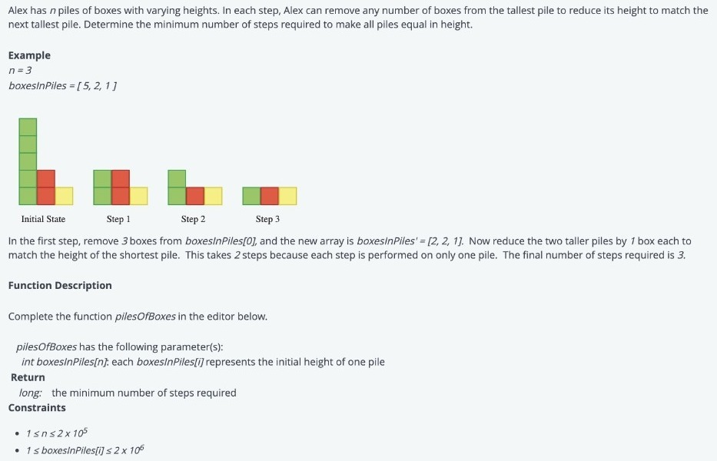
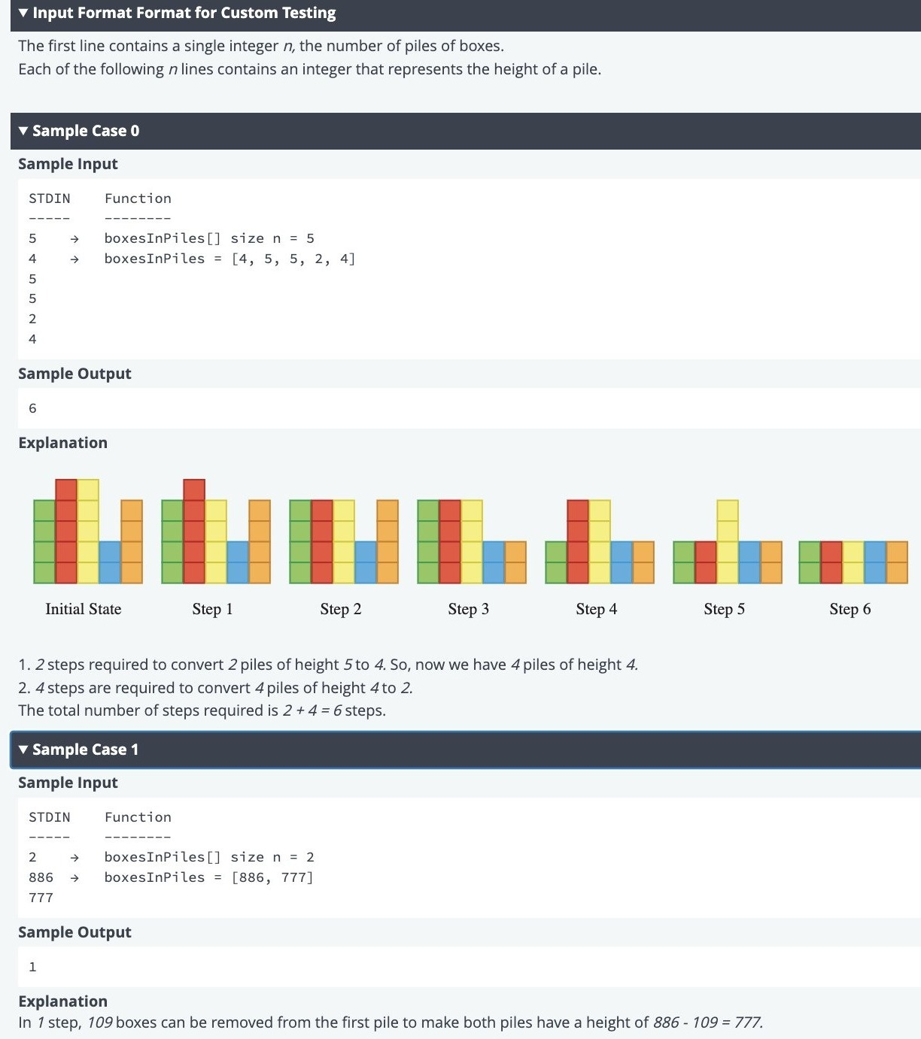
Understanding :-> You are given an array “A”; in one step select largest element of array and convert it to second largest element of the array

-> Tell the minimum number of steps such that all elements become equal

Observation :- All elements in final array will be equal to the smallest element of the array

Brute force solution :->

-> Find largest element of array and second largest element of array -> O(N.)

-> Let say largest element is at index “i” -> b[i] = second largest

-> Keep doing this until all array elements become equal

-> O(N*N.)
-> u = 0
while(u==0){
-> largest(b)
-> second_largest(b)
-> b[i] = second_largest

-> if all array elements are equal u = 1

}

Optimization. -> Use map to track frequency of each number and do the simulation efficiently for all equal numbers in 1 go

https://www.jdoodle.com/ia/1yOt

TC - O(N*logn) -> SortedMap

Takes O(N.) size space.

Py https://ideone.com/QQiT0a.

def min_steps(arr):
freq={}
for num in arr:
freq[num]=freq.get(num,0)+1
freq=dict(sorted(freq.items(),reverse=True))
cumulative=0
operations=0
values=list(freq.values())
for i in range(len(values)-1):
cumulative+=values[i]
operations+=cumulative
return operations

13]session 13

13a) Max Distance Between Two Occurrences
def maxDistance(arr):

# Stores element to first index mapping
mp = {}
res = 0

for i in range(len(arr)):

# If this is the first occurrence of the
# element, store its index
if arr[i] not in mp:
mp[arr[i]] = i

# Else update max distance
else:
res = max(res, i - mp[arr[i]])

return res

13b) First Unique Character in a String

Given a string s, find the first non-repeating character in it and return its index. If it does not exist, return -1.

Example 1:
Input: s = "leetcode"
Output: 0
Explanation:
The character 'l' at index 0 is the first character that does not occur at any other index.
Example 2:
Input: s = "loveleetcode"
Output: 2

def firstUniqChar(self, s):
"""
:type s: str
:rtype: int
"""

hm=defaultdict(int)
for i in range (len(s)-1,-1,-1):
hm[s[i]]+=1

for i in range(len(s)):
if hm[s[i]]==1:
return i

return -1

13c) Find Common Characters
Given a string array words, return an array of all characters that show up in all strings within the words (including duplicates). You may return the answer in any order.

Example 1:
Input: words = ["bella","label","roller"]
Output: ["e","l","l"]
Example 2:
Input: words = ["cool","lock","cook"]
Output: ["c","o"]

def commonChars(self, words):

refhm=defaultdict(int)

for ch in words[0]:
refhm[ch]+=1

for word in words:
curhm=defaultdict(int)
for ch in word:
curhm[ch]+=1

for ch in refhm:
refhm[ch]=min(refhm[ch],curhm[ch])
ans=[]
for ch in refhm:
for _ in range(refhm[ch]):
ans.append(ch)

return ans

14] Longest Consecutive Sequence

Given an unsorted array of integers nums, return the length of the longest consecutive elements sequence.
You must write an algorithm that runs in O(n) time.

Example 1:
Input: nums = [100,4,200,1,3,2]
Output: 4
Explanation: The longest consecutive elements sequence is [1, 2, 3, 4]. Therefore its length is 4.
Example 2:
Input: nums = [0,3,7,2,5,8,4,6,0,1]
Output: 9

def longestConsecutive(self, nums):
return 0 improves complexity (not really)"""

numSet=set(nums)
longest=0
seen=()
for num in numSet:
if (num-1) not in numSet:
length=0
while (num+length) in numSet:
length+=1
longest=max(longest,length)

return longest

15]XOR

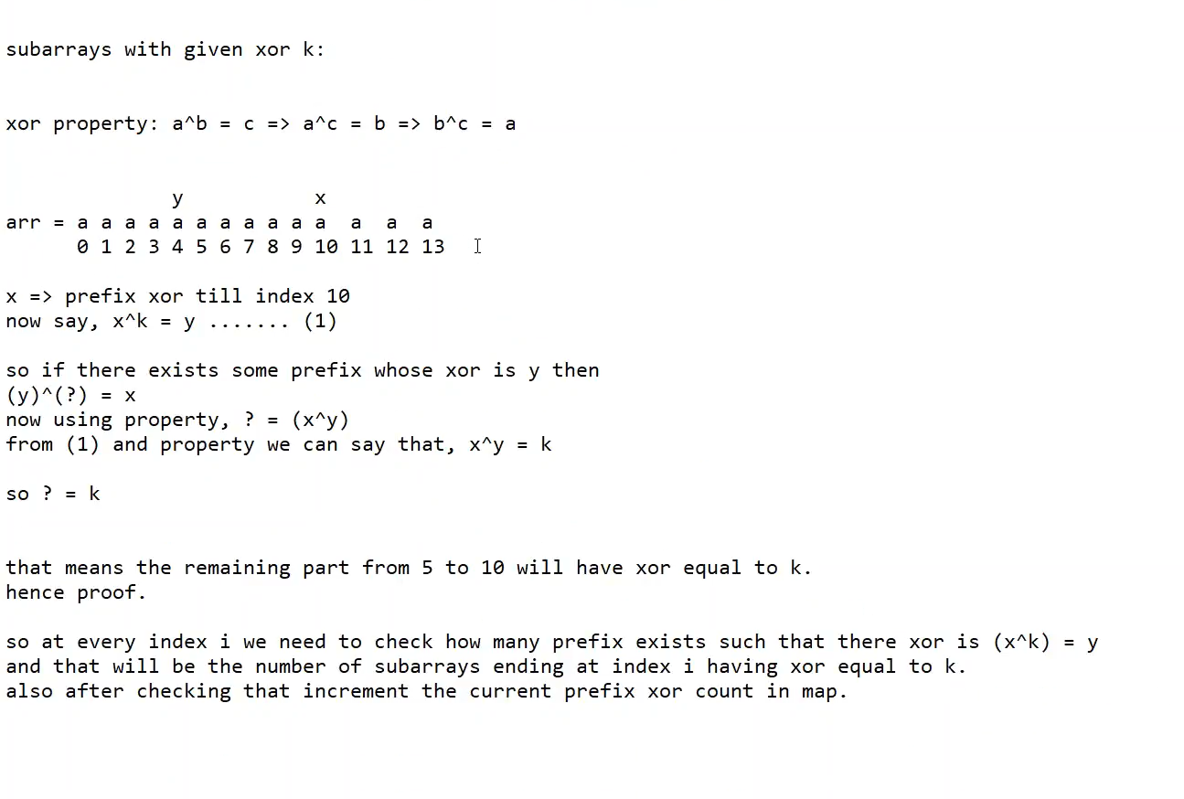

16]valid anagram

17]valid anagram

18]Count number of good subarrays

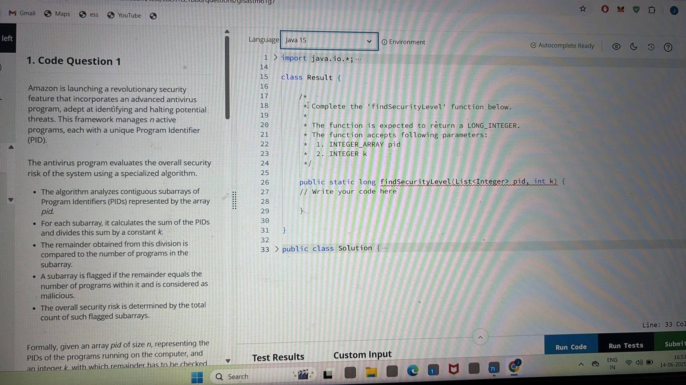

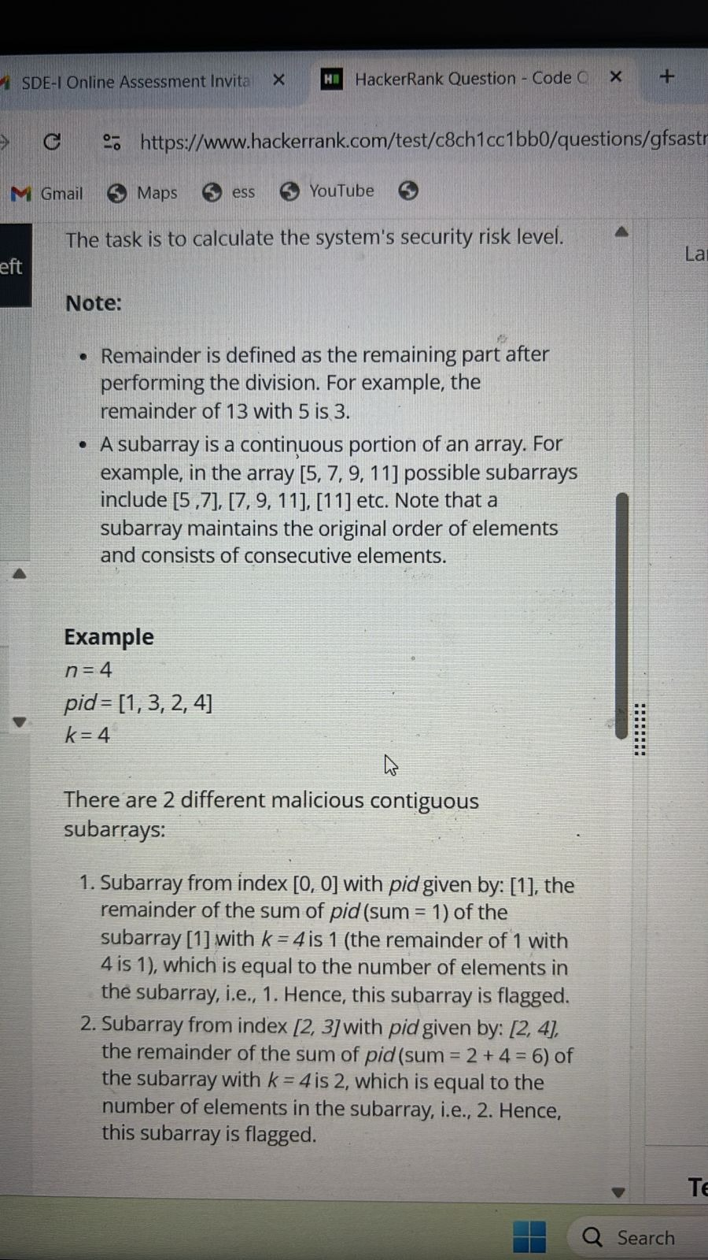
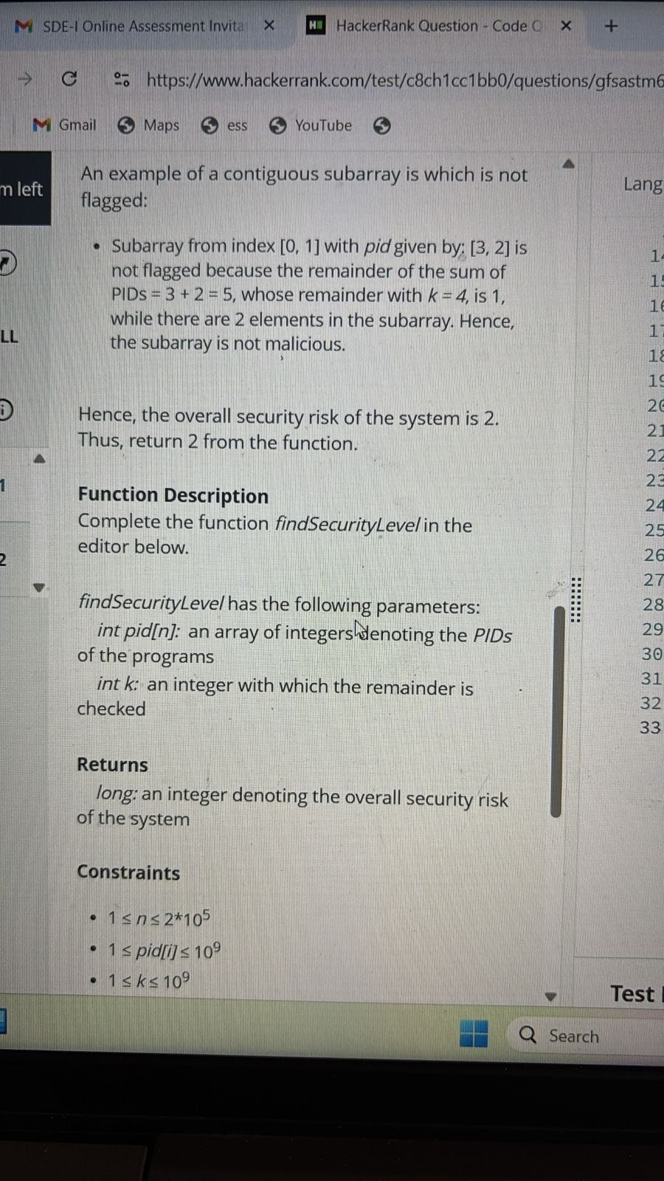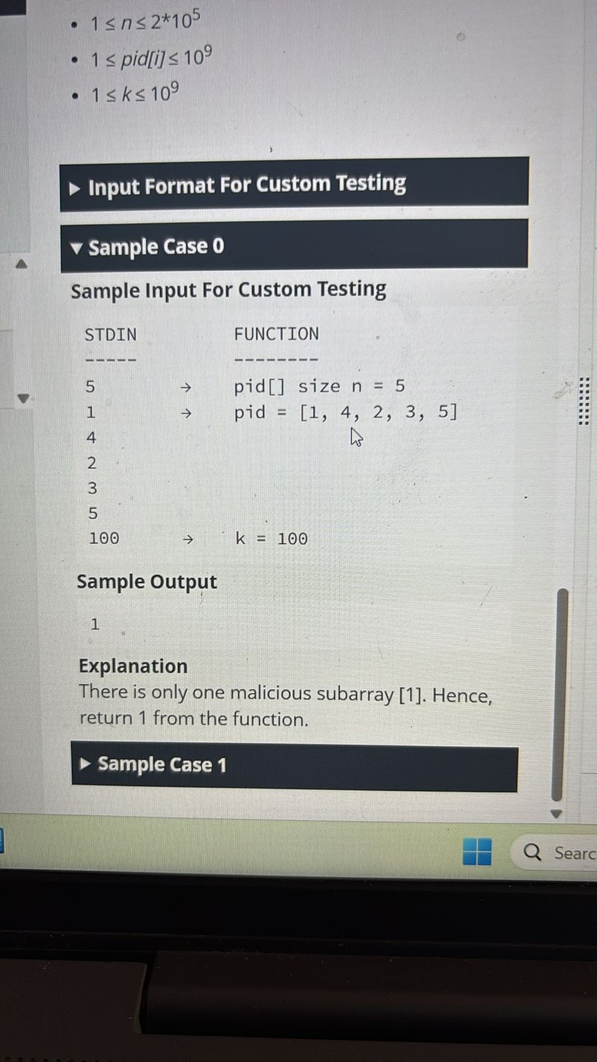
Understanding :-> Given an array :-> count the number of good subarrays;

Definition :-> [i……j] is good if sum[i……j]%k == length of that subarray

Brute Force :-> https://www.jdoodle.com/ia/1I47;

TC - O(N^2);

Easier version :-> Good subarray -> sum[i….j] = j-i+1 (sum==length)
from collections import defaultdict
n = int(input())
b = [0] + list(map(int, input().split()))
p = [0] * (n + 1)
for i in range(1, n + 1):
p[i] = p[i - 1] + b[i]
freq = defaultdict(int)
freq[0] = 1
count = 0
for j in range(1, n + 1):
y = p[j] - j
count += freq[y]
freq[y] += 1
print(count)

Analysis :-> p[j] - p[i-1] = j-i+1
:-> p[j] = sum(1….j);

:-> p[j]-j ⇒ p[i-1]-i+1 then [i….j]

-> we can calculate the count of good subarrays ending at index j;

-> Logic :- https://www.jdoodle.com/ia/1I48

TC - O(N);

-> Takes O(N) size space;
Py - https://ideone.com/hFsZLL
------------------------------------------------------------------------
Real version :-> Modulo Formula :->

-> (a + b)%k = (a%k + b%k) %k

-> (a - b) %k = (a%k - b%k + k) %k;

-> We have to find the count of subarrays such that sum[i……j]%k==(j-i+1)

-> (p[j] - p[i-1])%k = j-i+1

-> (p[j]%k - p[i-1] %k + k) %k = j-i+1

-> Can be re-written as (‘i’ on one side; ‘j’ on other side;) :->
-> (p[j]%k - j + k)%k == (p[i-1]%k -i + 1 + k)%k
-> For safety purpose; we add %k everywhere;

-> (p[j]%k -j%k + k)%k == (p[i-1]%k -i%k + 1%k + k)%k
(If k==1 return 0 in code given below ok)

Py - https://ideone.com/2QNgmc

from collections import defaultdict
n,k=map(int,input().split())
a=[0]+list(map(int,input().split()))
prefix=[0]*(n+1)
for i in range(1,n+1):
prefix[i]=prefix[i-1]+a[i]
freq=defaultdict(int)
freq[0]=1
count=0
for j in range(1,n+1):
mod_prefix=((prefix[j]%k-j%k+k)%k)
count+=freq[mod_prefix]
freq[mod_prefix]+=1
print(count)

19] Count how many LCT subsequences are in the string -> once done -> you are now allowed to insert any 1 char at any place in the string -> do it in such a way so that final count of LCT maximizes;

-> we count old_answer = count of “LCT” subsequences in the string

-> l = 0
-> lc = 0
-> n
-> string s;
fo(i,0,n-1){
if(s[i]=='L'){
l++;
}
if(s[i]=='C'){
lc = lc + l; l->[count of L from 0 to i-1]
}

}

print(lc)

->1st observation :- the only characters which you try to insert should be “L” or “C” or “T”

-> Case :-1 :-> Try to insert “L” -> where to insert “L”

-> If you insert “L” in middle of (0….i) and (i+1….n-1)
=> new_answer = old_answer + count of “CT” in the suffix[i+1….n-1]
=> maximizing :-> “L” should always be put at the start

-> answer1 = old_answer + count of “CT” in the string[0……n-1]

-> Case :-3 :-> Try to insert “T” -> where to insert “T” -> put in the end -> same analysis as before;

-> answer3 = old_answer + count of “LC” in the string[0……n-1]

-> Case :-2 :-> Insert C ->try all positions for “C”

-> If we try to insert “C” in middle of [0….i-1] and [i….n-1]

-> new_answer = old_answer + count of L from [0….i-1]*count of T from [i….n-1]

-> do this for each index “i” -> and take max of all of them -> answer2; and compare them with -> max(answer1,answer2,
answer3);

TC :- O(N);
Takes O(N) size space;

20] Stable subarrays, length>=3, first el==last el==sum btwn first and last el

Link -> https://leetcode.com/problems/stable-subarrays-with-equal-boundary-and-interior-sum/description/

Analysis :- Iterate all the subarrays and check which subarray is valid and increase the count

TC :- Brute Force currently

→ Try to count all valid subarrays ending at index “i” -> do this for each index “i” and sum it up

→ Logic for easy version :- https://www.jdoodle.com/ia/1Mlg

—> Actual version :--> You are at index “i” → you know sum = sum(a[0]+a[1]+......+a[i])

→ new_sum == Psum[i] - 2*a[i];

→ now find how many times is the prefix_sum == new_sum → those many times a valid subarray is born baby which is ending at index “i”

→ you need to make sure the valid prefix sums ending with the last number == a[i]

→ hashmap <pair<prefix_sum,last_number>>,frequency>

→ at index “i” → you ask for map[{newsum,a[i]}]

→ O(NlogN)

from collections import defaultdict
from typing import List

class Solution:
def countStableSubarrays(self, capacity: List[int]) -> int:
g = defaultdict(int)
total = 0
ans = 0

for c in capacity:
total += c
desired_sum = total - 2 * c
if (desired_sum, c) in g:
ans += g[(desired_sum, c)]
g[(total, c)] += 1

n = len(capacity)
for i in range(n - 1):
# Subarrays of size 2 of type [0,0] got overcounted
if capacity[i] == 0 and capacity[i + 1] == 0:
ans -= 1

return ans

